The Journey to the Cross
March 11, 2018
“God So Loved the World” (John 3:14-21)
1. Introduction: John 3:16
The Wikipedia entry for John 3:16 begins with these words, “John 3:16 is one of the most widely quoted verses from the Bible and has been called the most famous Bible verse. It has also been called the "Gospel in a nutshell", because it is considered a summary of the central theme of traditional Christianity” (https://en.wikipedia.org/wiki/John_3:16).
Even though this is a Wikipedia entry, it contains a lot of good information about John 3:16. It is a widely quoted and well-known Bible verse. Many of us can quote it from memory or at least summarize its main idea. It is frequently used as memory verse for children in Sunday school classes. For instance, I recall memorizing it at Daily Vacation Bible School when I was a child. It is also recognizable within pop culture. For instance, some people hold up “John 3:16” signs at sporting events. This verse has had a lasting impact on the lives of many people, myself included. Many years ago, someone told me that they had heard a sermon where the preacher connected all the 3:16’s from every book of the Bible together, claiming that it was the golden thread that held the Bible together. Now that would have been quite the sermon to hear!
So, I’m more than a little apprehensive about preaching on such a well-known Bible verse. What can I say about this well-loved, oft-quoted, and much-used Bible verse that hasn’t already been said? Perhaps, my task is not to find something new to say about John 3:16. Perhaps, I must simply remind all of us of the wonderful truth contained in this verse which articulates the “Gospel in a nutshell.”
2. A Conversation between Jesus and Nicodemus: You must be born again
It’s easy to miss the fact that John 3:16 is part of a much larger discussion between Jesus and Nicodemus, who was a Pharisee and a member of the Jewish ruling council (3:1). During Jesus’ visit to Jerusalem, Nicodemus arranged a private meeting with him. His opening statement demonstrates a certain respect for Jesus, but not a full-blown belief in him. He addresses Jesus as “Teacher” and acknowledges that his miraculous acts are indicators that that God has sent him (3:2). But as the discussion continues it becomes clear that Jesus has come from God in a way that Nicodemus could never have anticipated. Jesus has descended from heaven as the unique Son of God in order to reconcile people to God. But before Jesus reveals that truth, he nudges the conversation from its introductory small talk to a much higher, spiritual level.
Undaunted, Jesus confronted this powerful religious leader with these words - “I tell you the truth, unless you are born again, you cannot see the Kingdom of God” (3:3). Even though Nicodemus was a member of the most devout of the Jewish religious groups and had a seat on the Jewish religious council, he still needed a spiritual rebirth. This is a powerful lesson for all of us because no matter how religious and devout you think you are, a spiritual rebirth is essential for inclusion in God’s kingdom. But Jesus’ provocative expression, “unless you are born again,” led to a misunderstanding on the part of Nicodemus. He thought that Jesus was talking about physical birth, so he questions this idea by pointing out the impossibility of going back to the womb to be reborn (3:4). Jesus, of course, clarified things for Nicodemus, when he said, “I assure you, no one can enter the Kingdom of God without being born of water and the Spirit. Humans can reproduce only human life, but the Holy Spirit gives birth to spiritual life” (3:5-6)
Now we’re unlikely to misunderstand Jesus’ words in the same way that Nicodemus did, but the expression, “born again” evokes different responses among people. When people hear this expression, different connotations come to mind. In North American culture, primarily in the US the term “born-again Christian” is sometimes associated with a view of Christianity that includes very specific views on science, politics and social issues. Sometimes this expression has been used to establish a religious pecking order within Christianity. Someone might exert their spiritual superiority over another Christian from a different church by saying, “Well, I’m a born-again Christian.” Finally, for some this expression may conjure up an image of Christianity that is lively, exuberant, enthusiastic and a bit noisier than what some of us are accustomed to. With all these caveats in minds, let me say that I find the image very meaningful.
During my journey as a spiritual seeker I was supported, encouraged and prayed for by my best friend and his youth group. It was at that time that I began to read the Bible with great interest. Like many, I started with the John’s Gospel and I found its message gripping. But I struggled to take the step of faith. I knew that there was a lot of bad stuff in my life and I was frightened by the prospect of becoming a Christian and failing at it. I wrongly thought that I had to get my act together and then start to follow Christ. But then I read Jesus’ words to Nicodemus, “no one can see the kingdom of God unless he is born again” (3:3). God was offering me a new life and a new beginning, and although I didn’t completely understand what this new life would entail, I realized that I couldn’t manufacture it on my own – it was God’s undertaking. So, I didn’t have to get my act together to start this new life in the Spirit. Later in the chapter I read, “For God so loved the world that he gave his one and only Son, that whoever believes in him shall not perish but have eternal life” (3:16). God’s love broke through and I realized that the new life that God was offering me was gift and that all I needed to do was to take the step of faith and trust in Jesus. I knelt at my bedside and prayed and the great adventure of following Jesus began.
My experience was much like John Stott’s, the famous Anglican clergyman. He recounted his experience of coming to Christ in his book, Basic Christianity. “A boy in his later teens knelt at his bedside one Sunday night in the dormitory of his school. In a simple, matter-of-fact but definite way he told Christ that he had made rather a mess of his life so far; he confessed his sins; he thanked Christ for dying for him; and he asked him to come into his life. The following day he wrote in his diary:
‘Yesterday really was an eventful day! Up till now Christ has been on the circumference and I have but asked him to guide me instead of giving him complete control. Behold, he stand at the door and knocks. I have heard him and now he had come into my house. He has cleansed it and now rules in it.’
And the day after:
‘I really have felt an immense and new joy throughout today. It is the joy of being at peace with the world and being in touch with God. How well do I know now that he rules me and that I never really knew him before.’
Stott ends by saying this: “These are extracts from my own diary. I venture to quote them because I do not want you to think that I am recommending to you a step that I have not taken myself. Are you a Christian? A real and committed Christian? Your answer depends on another question – not whether you go to church or not, believe the creed or not, or lead a decent life or not (important as all these are in their place), but rather this: which side of the door is Jesus Christ? Is he inside or outside? That is the crucial issue” (Stott, Basic Christianity, pp. 128-29).
When we open the door of our lives to Jesus he brings us new life by his Spirit. So “being born again” is not something to be feared, rather it is something to be embraced. It is God’s gracious act of changing our self-centred, sinful human nature into something beautiful. The Apostle Paul proclaims, “Now we look inside, and what we see is that anyone united with the Messiah gets a fresh start, is created new. The old life is gone; a new life burgeons!” (2 Corinthians 5:17, The Message). What a wonderful change that Jesus brings – a new heart, a new nature, a new birth and a new creation! The theological term for God’s transforming work is regeneration, which is defined as “the miraculous transformation of the individual and implantation of spiritual energy” (Millard Erickson, Christian Theology, p. 873). Jesus made it very clear to Nicodemus that this tremendous inward change is the work of the Holy Spirit. Human effort or the flesh cannot bring it about this transformation because “Humans can reproduce only human life, but the Holy Spirit gives birth to spiritual life” (3:6). Emphasizing the necessity of this rebirth from above, Jesus emphatically declared, “You must be born again (or from above)” (3:7). He went on to emphasize the reality of this spiritual birth, even though it is mysterious and invisible. Like the blowing wind, the Spirit works in people’s lives. While we cannot see the wind or the Spirit, we can observe the transforming effects of the Spirit in people’s lives (3:8). So, what is the Spirit’s “wind” like in your life right now? Still as a summer night? A few little gusts? Howling? At full sail?

3. The Conversation Continues: For God so loved the world
Taking in all of Jesus’ words, Nicodemus simply asked, “How are these things possible?” (3:9). In response, Jesus expressed his astonishment at Nicodemus’ inability to grasp his teaching on the spiritual rebirth (3:9-12). But Jesus patiently went on to explain that this spiritual rebirth could only come about as the result of his crucifixion, resurrection and ascension. Jesus was in the unique position to express these heavenly truths to Nicodemus because he came from heaven to earth to reveal them to all humanity (3:13). Yet Jesus’ descent to the earth in the incarnation culminated with his ascent to back to the Father via the cross. His ascent on the cross is the way that humanity is granted new and enduring life.
To illustrate his point Jesus made an analogy between an event from Israel’s past and his mission of salvation (3:14-15). Jesus’ reference to the bronze snake on a pole points to a story from Numbers 21:4-9. In that story the Israelites were speaking against God and as a result they were plagued with poisonous snakes. When the people began to die from the snakebites, they recognized their sin and asked Moses to intercede for them. So, God instructed Moses to lift up a bronze snake on a pole and to tell those who were bitten to look to the bronze snake in order to live. In the same way, the Son of Man must be lifted up in order to give life to people. But the analogy is not perfect. The bronze snake merely provided temporary respite from physical death, but the Son of Man will provide eternal life to all who trust in him (3:15). For us, this is a clear reference to Jesus’ death on the cross, yet this intriguing verb, to lift up (ὑψόω) has a double meaning. It not only refers to the physical act of Jesus being raised on the cross, but it also speaks of his glorious resurrection and ascension. So the salvation that Jesus provides springs from the entire process of the incarnation. The song, “I life your name on high” illustrates this idea quite well.
“You came from heaven to earth
To show the way
From the earth to the cross
My debt to pay
From the cross to the grave
From the grave to the sky
Lord I lift Your name on high”
Jesus did all this so that eternal life, that is the new life as God’s children, begotten of the Father and reborn by the Spirit, could be given to all who trust in him. God did all this because he loves us. “For God loved the world so much that he gave his one and only Son so that so that everyone who believes in him will not perish but have eternal life” (3:16). God’s love for a disobedient and rebellious world moved him to give his only Son to and for the world. So we don’t have to climb the highest mountain or stack up good deeds or get our act together to receive this new, abundant and eternal life. All one needs to do is to put his or her trust in Jesus and accept God’s gift of life. God’s invitation is open to everyone as verse 17 assures us, “God sent his Son into the world not to judge the world, but to save the world through him.”
So, has God’s love broken through in your life? When I became a Christian the music of Keith Green was very meaningful to me. One of his songs entitled, “Your love broke through” spoke very clearly of my journey.
“All my life I've been searching for that crazy missing part
And with one touch, you just rolled away the stone that held my heart
And now I see that the answer was as easy, as just asking you in
And I am so sure I could never doubt your gentle touch again
It's like the power of the wind
Like waking up from the longest dream, how real it seemed
Until your love broke through
I've been lost in a fantasy, that blinded me
Until your love, until your love, broke through”
Are you searching for that crazy missing part? Is there a stone rolled in front of your heart? I pray that God’s love would break through. God loves you and he offers you new, abundant and eternal life.
Below, I’ve reproduced a spiritual inventory that you can look at and think about. Its purpose is to get all of us to reflect on where we are at in our walk with God. I invite you to consider it, thoughtfully and prayerfully. If you need to pray or talk to someone about this, there are lots of people here, myself included, who would love to help you out.

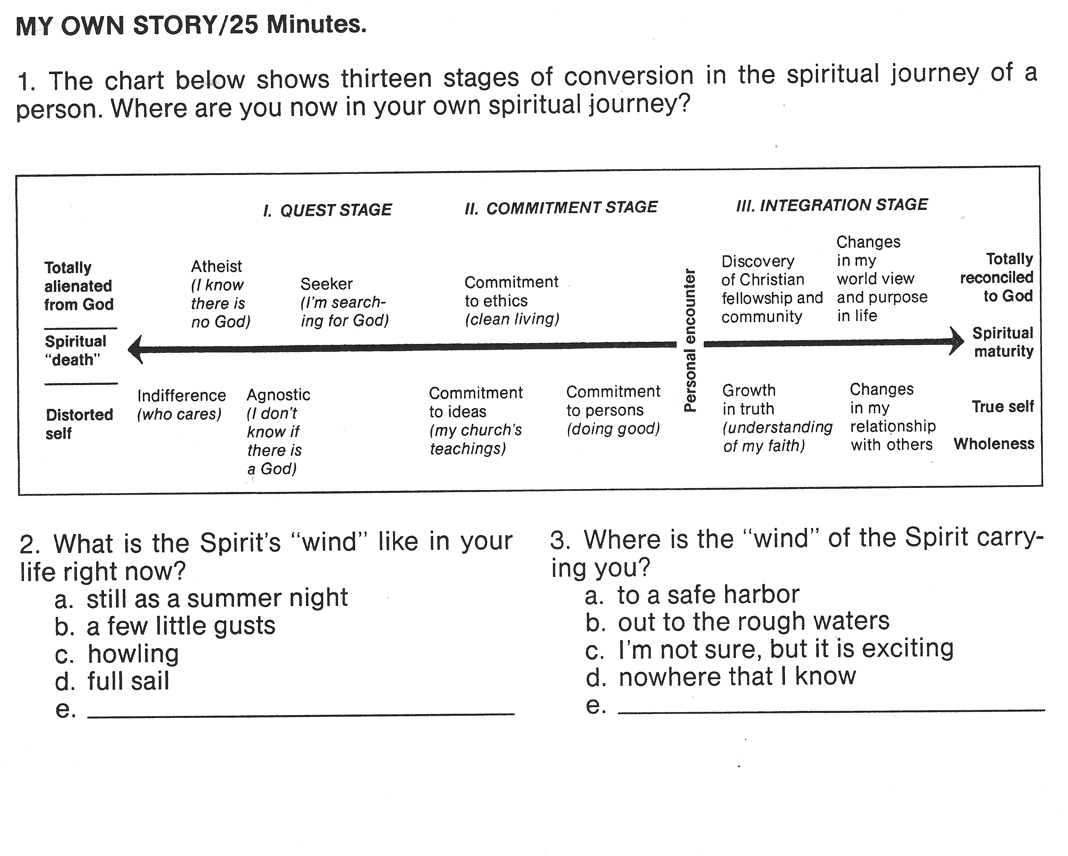
(source: Serendipity Bible)

